**NAME – KARAN DAS**

**USER ID – 34763**

**MAIL-** [**karannnx20@gmail.com**](mailto:karannnx20@gmail.com)

**Date – 8th Aug 2025**

**Topic Assignment:**

1. Introducing to Cmdlets
2. The PowerShell Pipeline
3. Key Cmdlets
4. WMI & PowerShell
5. Pipeline Filtering & Operators
6. Input, Output & Formatting
7. Scripting Overview

**Practice Activity :-**

**1. Introducing to Cmdlets .**

Cmdlets are basic commands used in PowerShell to do tasks like getting files, managing services, or checking system info.

They follow a Verb-Noun format like Get-Help or Start-Service.

You can use them alone or combine them to do more complex actions.

Example:  
Get-Process shows running apps.  
Stop-Service stops a service.

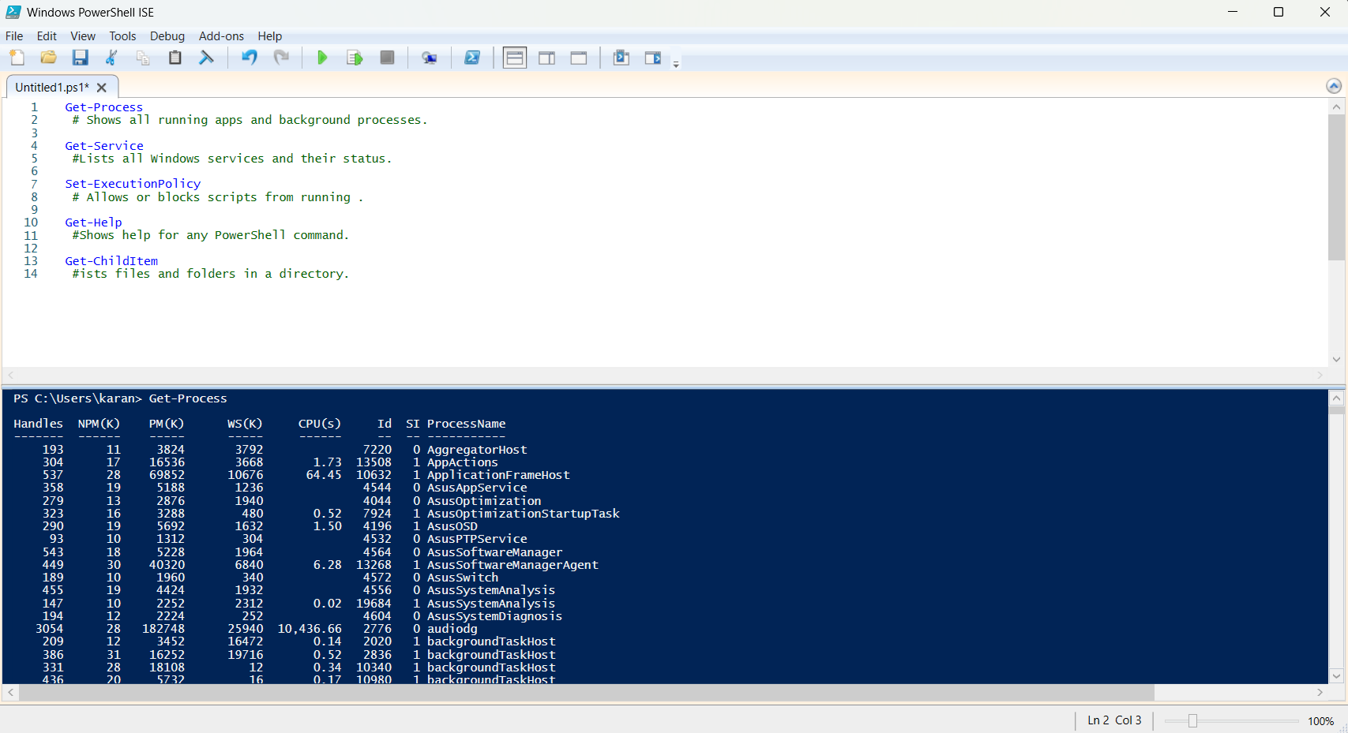

**2. The PowerShell Pipeline .**

The pipeline in PowerShell lets you connect commands together using the | symbol.

It passes the output of one command as the input to the next.

This helps you do more in a single line without needing extra code.

Example:

Get-Process | Where-Object {$_.CPU -gt 100}

This gets only the processes using more than 100 units of CPU.

The pipeline makes PowerShell powerful and efficient.

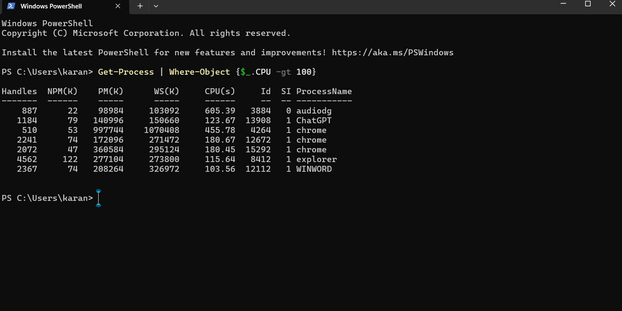

**3. Key Cmdlets.**

Some important Key Cmdlets:-

* Get-Help – Shows help for commands
* Get-Command – Lists all available cmdlets
* Get-Process – Shows running processes
* Start-Service – Starts a Windows service
* Stop-Service – Stops a Windows service
* Set-ExecutionPolicy – Changes script running rules
* Get-Content – Reads content from a file
* New-Item – Creates a new file or folder
* Remove-Item – Deletes a file or folder
* Copy-Item – Copies a file or folder

These cmdlets help with system management, file handling, and automation tasks.

**4. WMI & PowerShell.**

**WMI** stands for Windows Management Instrumentation.

It lets you access system information like hardware, software, and services.

**PowerShell** can use WMI to get or change this info easily.

Example:

Get-WmiObject -Class Win32_OperatingSystem

This shows details about your Windows OS like version, build number, and more.

WMI is useful for tasks like checking disk space, system info, or managing services remotely — all through PowerShell.

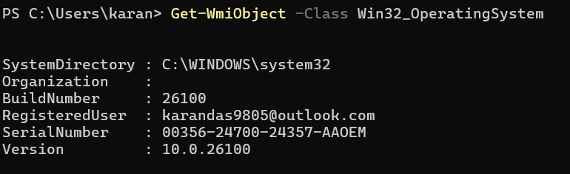

**5. Pipeline Filtering & Operators .**

**Pipeline filtering** in PowerShell means narrowing down results using conditions.

You use it with the | symbol and filtering cmdlets like Where-Object or Select-Object.

Example:

Get-Process | Where-Object {$_.CPU -gt 100}

This filters only the processes using more than 100 CPU units.

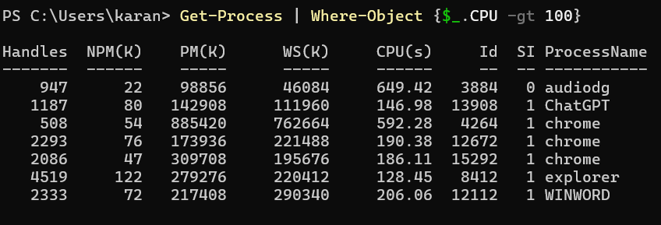

**Operators** help build those conditions:-

* -eq → equals
* -ne → not equal
* -gt → greater than
* -lt → less than
* -like → matches pattern (wildcards)
* -and, -or, -not → logical operators

Example with operator:

Get-Service | Where-Object {$_.Status -eq "Running"}

This shows only running services.

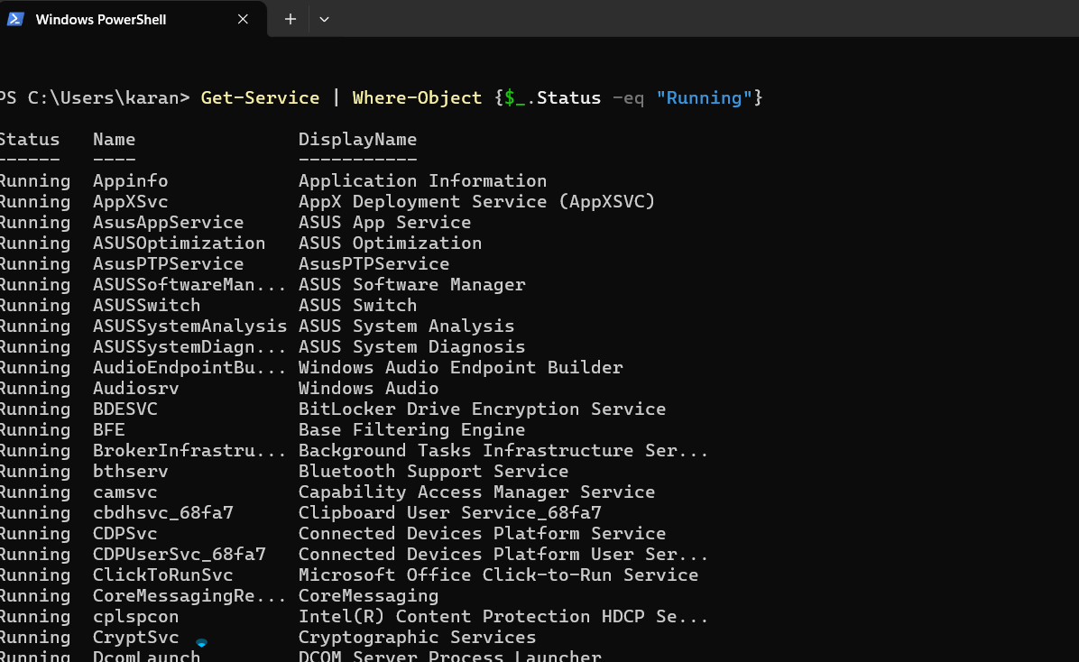

Filtering and operators make it easy to get just the data you need.

**6. Input, Output & Formatting .**

Input in PowerShell is the data you give to a command or script.

Output is what the command returns after running.

Formatting is how that output looks when shown on the screen.

Example of Input & Output:

* Input: The command (Get-Service)
* Output: A list of all services with their names and statuses

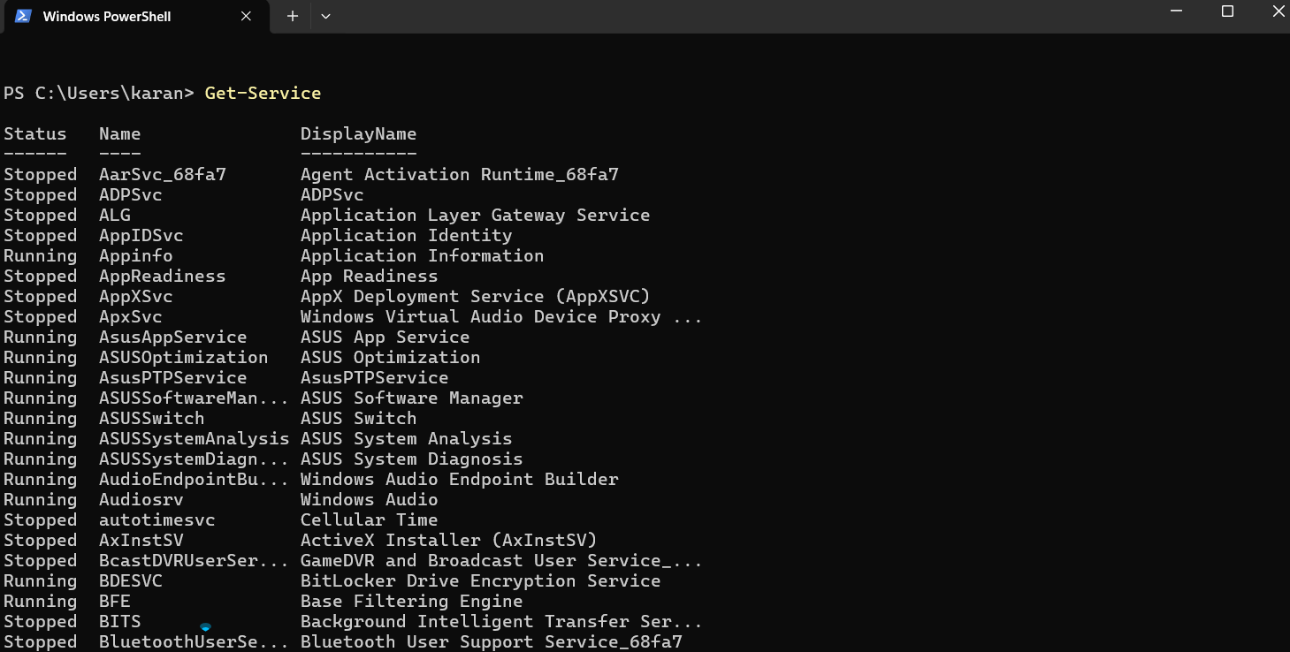

**Formatting Cmdlets** help change how the output is shown:

* Format-Table – Shows data in table form
* Format-List – Shows detailed data in list form
* Out-File – Sends output to a file
* Out-GridView – Opens output in a grid window
* Out-Host – Sends output to the screen (default)

Example:

Get-Process | Format-Table Name, CPU

This shows process names and CPU usage in a neat table format.

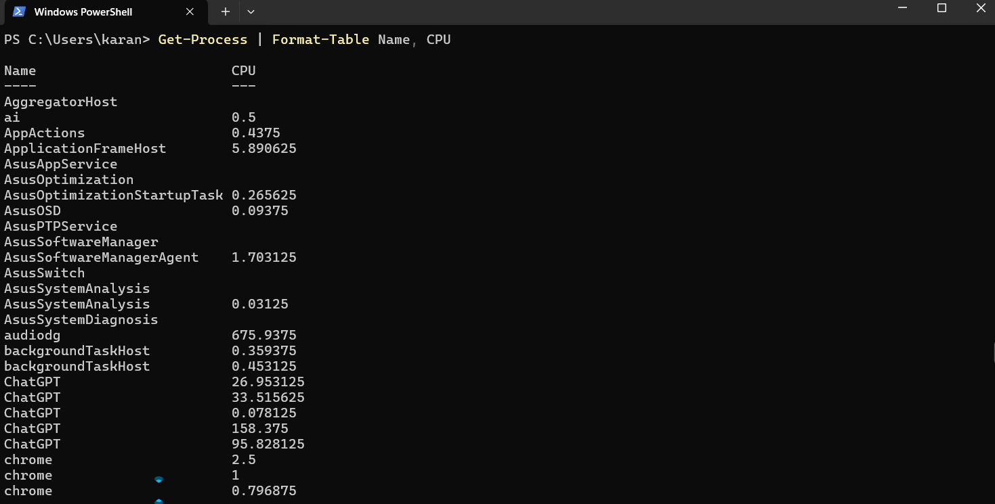

Formatting helps make output easier to read or save.

**7. Scripting Overview.**

**Scripting Overview:-**

PowerShell scripting means writing a series of commands in a .ps1 file to automate tasks.

Instead of typing each command one by one, you save them in a script and run all at once.

Why we use scripts?

* Save time
* Repeat tasks easily
* Reduce manual errors
* Automate system tasks, app installs, reports, etc.

Example:-

Project number 1:- Automate a Task with a Cmdlet Script (AutomationTask1.ps1)

To run a script:

1. Save it as .ps1 file
2. Run in PowerShell:

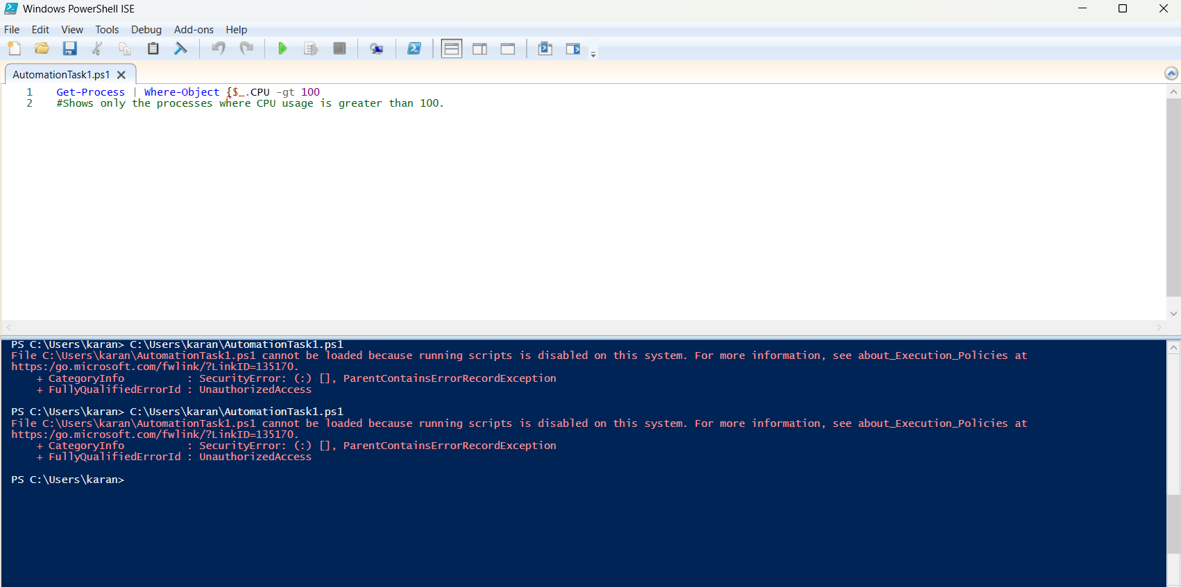

It cannot be loaded because running scripts is disabled on this system.

Project number 2 :- Exploring Cmdlet Syntax

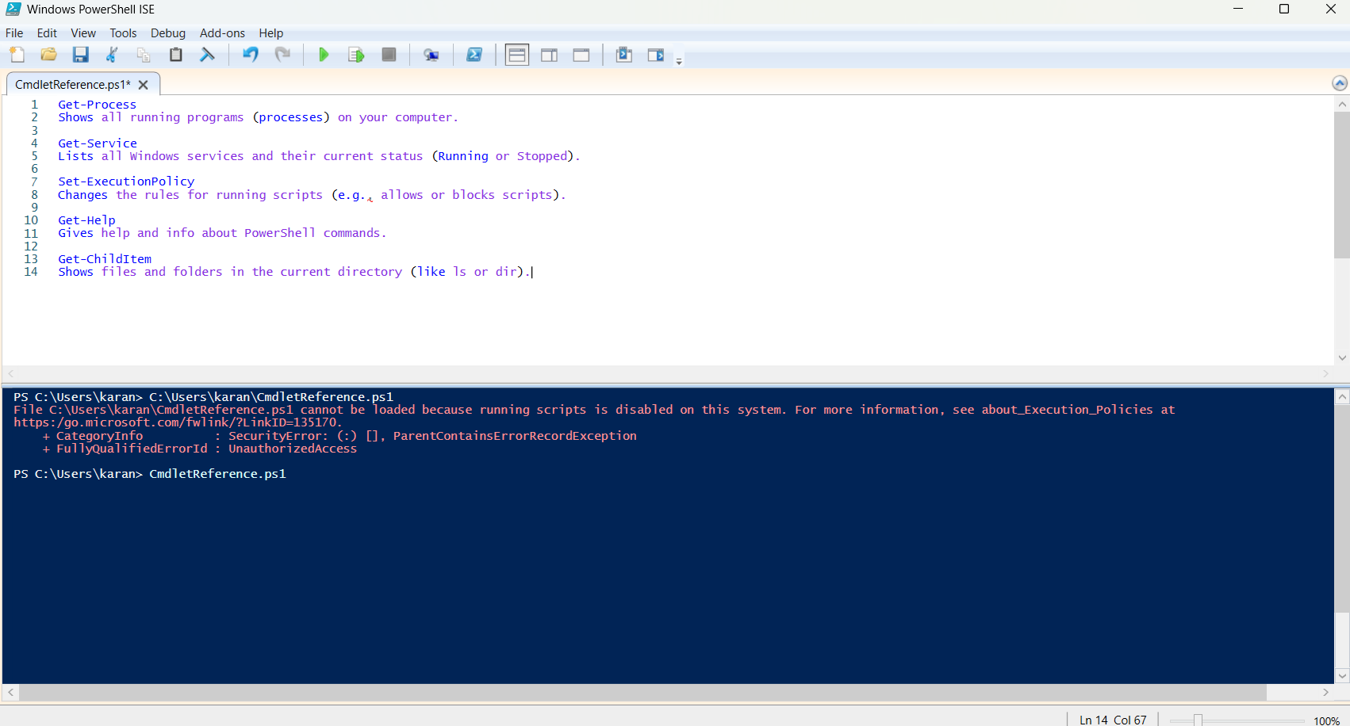

It cannot be loaded because running scripts is disabled on this system.

**Project number 3 :- Create a PowerShell Cmdlet Cheat Sheet (PowerShellCheatSheet.md)**

* Get-Process – Shows all running processes on your system.
* Get-Service – Lists all services and their status.
* Stop-Service – Stops a running service.
* Start-Service – Starts a stopped service.
* Get-EventLog – Views events from Windows logs.
* Get-Item – Shows details of a specific file or folder.
* Set-Location – Changes the current working directory.
* Copy-Item – Copies a file or folder to another location.
* Move-Item – Moves a file or folder to another location.
* Remove-Item – Deletes a file or folder.
* Rename-Item – Renames a file or folder.
* Get-Content – Reads the content of a file.
* Set-Content – Writes or replaces content in a file.
* Select-String – Searches text in files (like grep).
* Get-ADUser – Retrieves information about an Active Directory user.
* New-ADUser – Creates a new Active Directory user.
* Get-ComputerInfo – Displays detailed system information.
* Set-Date – Changes the system date and time.
* Where-Object – Filters results based on a condition.
* Sort-Object – Sorts output by a property.
* Set-ExecutionPolicy – Changes PowerShell script execution rules.
* Get-Help – Shows help for commands and concepts.
* Get-ChildItem – Lists files and folders in a directory.
* Remove-Item – (Duplicate) Deletes a file or folder.
* Test-Connection – Checks if a device is reachable (like ping).
* Get-NetIPAddress – Shows IP address information.
* Get-Command – Lists all available PowerShell commands.

Top of Form

Bottom of Form